Experiment No: 08
Experiment Name: CPU Scheduling Algorithms Round Robin and Priority(Non Preemptive)
Theory: CPU scheduling is a core operating system function that determines the order in which processes access the processor. Round Robin is a preemptive CPU scheduling algorithm where each process receives a fixed time slice called a time quantum. Processes execute in cyclic order using a ready queue, and if a process exceeds its quantum, it is preempted and moved to the queue's rear. Priority Scheduling (Non-Preemptive) selects the process with the highest priority (lowest priority number) from arrived processes and executes it until completion without interruption. Both algorithms are evaluated using completion time (CT), turnaround time (TAT = CT − AT), and waiting time (WT = TAT − BT). Round Robin ensures fairness and responsiveness, while priority scheduling favors critical tasks, though it may cause starvation of lower-priority processes.

Code & Output:
- Round Robin Scheduling: The program initializes five processes with arrival and burst times, and sets a time quantum of 2 units. It uses a deque as a ready queue and tracks remaining burst times for each process. Processes are sorted by arrival time, and the scheduler runs a loop that adds newly arrived processes to the queue. The front process is dequeued, executed for either the time quantum or its remaining burst time (whichever is smaller), and the elapsed time is updated. If the process still has remaining burst time, it is requeued; otherwise, its completion time is recorded. New arrivals during execution are also added to the queue. After scheduling, completion time, turnaround time, and waiting time are calculated and displayed in a table with averages, followed by a Gantt chart showing the preemptive execution sequence.

- # Round Robin Scheduling
- from collections import deque

- processes = [
- {"id": "P1", "at": 0, "bt": 8},
- {"id": "P2", "at": 2, "bt": 4},
- {"id": "P3", "at": 4, "bt": 9},
- {"id": "P4", "at": 6, "bt": 3},
- {"id": "P5", "at": 8, "bt": 5},
- ]
- TQ = 2

- time = 0
- queue = deque()
- remaining_bt = {p["id"]: p["bt"] for p in processes}
- arrival_map = {p["id"]: p["at"] for p in processes}
- completed = {}
- gantt = []

- processes.sort(key=lambda x: x["at"])
- i = 0

- while i < len(processes) or queue:
- while i < len(processes) and processes[i]["at"] <= time:
- queue.append(processes[i]["id"])
- i += 1

- if not queue:
- time += 1
- continue

- current = queue.popleft()

- start = time
- exec_time = min(TQ, remaining_bt[current])
- time += exec_time
- remaining_bt[current] -= exec_time

- gantt.append((current, start, time))

- while i < len(processes) and processes[i]["at"] <= time:
- queue.append(processes[i]["id"])
- i += 1

- if remaining_bt[current] > 0:
- queue.append(current)
- else:
- completed[current] = time

- # Metrics
- print("\n")
- total_tat = total_wt = 0
- print("P\tAT\tBT\tCT\tTAT\tWT")
- for p in processes:
- ct = completed[p["id"]]
- tat = ct - p["at"]
- wt = tat - p["bt"]
- total_tat += tat
- total_wt += wt
- print(f"{p['id']}\t{p['at']}\t{p['bt']}\t{ct}\t{tat}\t{wt}")

- n = len(processes)
- print(f"\nAverage TAT = {total_tat/n:.2f}")
- print(f"Average WT = {total_wt/n:.2f}")

- # Gantt chart
- print("\nGantt Chart:")
- for p in gantt:
- print(f"| {p[0]} ", end="")
- print("|")

- print(gantt[0][1], end="")
- for p in gantt:
- print(f" {p[2]}", end="")
- print("\n")

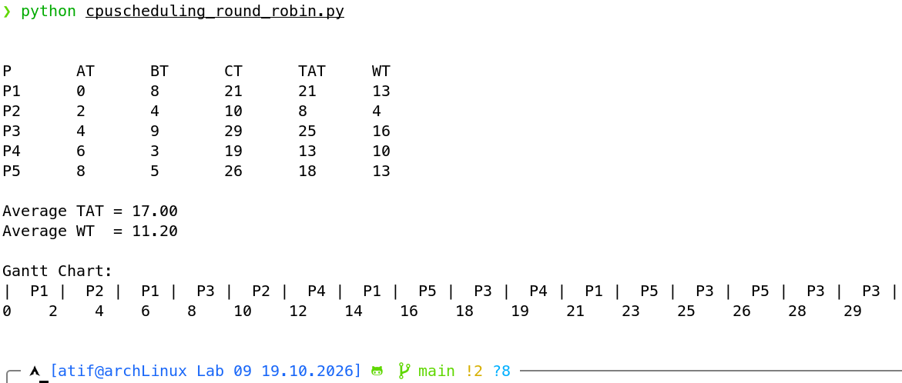

Fig: Round Robin Output

2. Priority Scheduling (Non-Preemptive): This program defines five processes with arrival times, burst times, and priority values, where lower numbers indicate higher priority. The scheduler iterates until all processes complete. At each step, it collects processes that have arrived and are not yet finished. If none are available, the timer advances. Otherwise, the process with the lowest priority number is selected; ties are broken by arrival time and process ID. The selected process runs to completion without preemption, and its completion time is recorded. After all processes finish, turnaround time and waiting time are computed using the standard formulas and displayed in a table with averages, accompanied by a Gantt chart illustrating the non-preemptive priority-based execution order.

- # Priority Scheduling (Non-Preemptive).

- processes = [
- {"id": "P1", "at": 0, "bt": 10, "pr": 3},
- {"id": "P2", "at": 1, "bt": 5, "pr": 1},
- {"id": "P3", "at": 2, "bt": 8, "pr": 4},
- {"id": "P4", "at": 3, "bt": 6, "pr": 2},
- {"id": "P5", "at": 4, "bt": 4, "pr": 5},
- ]

- # Initialization
- time = 0
- completed = {}
- gantt = []

- # Start simulation
- while len(completed) < len(processes):
- available = [
- p for p in processes
- if p["at"] <= time and p["id"] not in completed
- ]

- if not available:
- time += 1
- continue

- current = min(available, key=lambda p: (p["pr"], p["at"], p["id"]))
- pid = current["id"]

- start = time
- time += current["bt"]
- completed[pid] = time

- gantt.append((pid, start, time))

- # metrics
- print("\n")
- total_tat = total_wt = 0
- print("\nP\tAT\tBT\tPR\tCT\tTAT\tWT")
- for p in processes:
- ct = completed[p["id"]]
- tat = ct - p["at"]
- wt = tat - p["bt"]
- total_tat += tat
- total_wt += wt
- print(f"{p['id']}\t{p['at']}\t{p['bt']}\t{p['pr']}\t{ct}\t{tat}\t{wt}")

- n = len(processes)
- print(f"\nAverage TAT = {total_tat/n:.2f}")
- print(f"Average WT = {total_wt/n:.2f}")

- print("\nGantt Chart:")
- for p in gantt:
- print(f"| {p[0]} ", end="")
- print("|")

- print(gantt[0][1], end="")
- for p in gantt:
- print(f" {p[2]}", end="")
- print("\n")
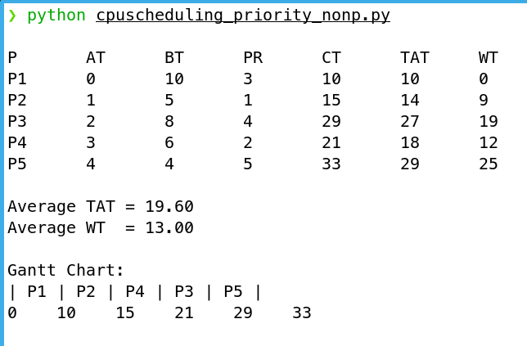

Fig: Priority Scheduling (Non-Preemptive) Output

Discussion:
This experiment simulated Round Robin and Priority scheduling algorithms to analyze their behavior in CPU management. Round Robin provided fair allocation through fixed time quantum, preventing starvation but increasing context switches. Priority scheduling favored urgent tasks with lower priority numbers, minimizing response time for critical processes though risking starvation for lower-priority ones. Both algorithms demonstrated how scheduling policies directly impact turnaround time, waiting time, and system throughput. The Gantt charts visually confirmed Round Robin's preemptive nature against Priority's non-preemptive execution. These findings highlight the trade-off between fairness and responsiveness in operating system design, essential knowledge for optimizing multi-tasking environments.

